| **Project Title** | **Customer Behavior Analysis** |
| --- | --- |
| **Skills take away From This Project** | **SQL for Data Analysis ,Database Management , Python for Database Operations,customer Journey & Marketing Analytics, Business Insights & Decision-Making** |
| **Domain** | **Marketing & Customer Analytics** |

**Problem Statement:**

ShopEasy, an online retail business, is experiencing a decline in **customer engagement and conversion rates**, despite investing heavily in marketing campaigns. The company has observed:

* **Reduced Customer Interactions**: Fewer customers are engaging with the website and marketing content.
* **Decreased Conversion Rates**: A decline in the percentage of site visitors making purchases.
* **High Marketing Expenses**: Increased spending on digital marketing but without a proportional increase in revenue.
* **Customer Feedback Gaps**: Poorly understood customer preferences due to lack of structured feedback analysis.

To address these challenges, **ShopEasy's Marketing and Customer Experience teams** have reached out for a data-driven solution that analyzes **customer behavior, reviews, and journey patterns** using **SQL and Python**.

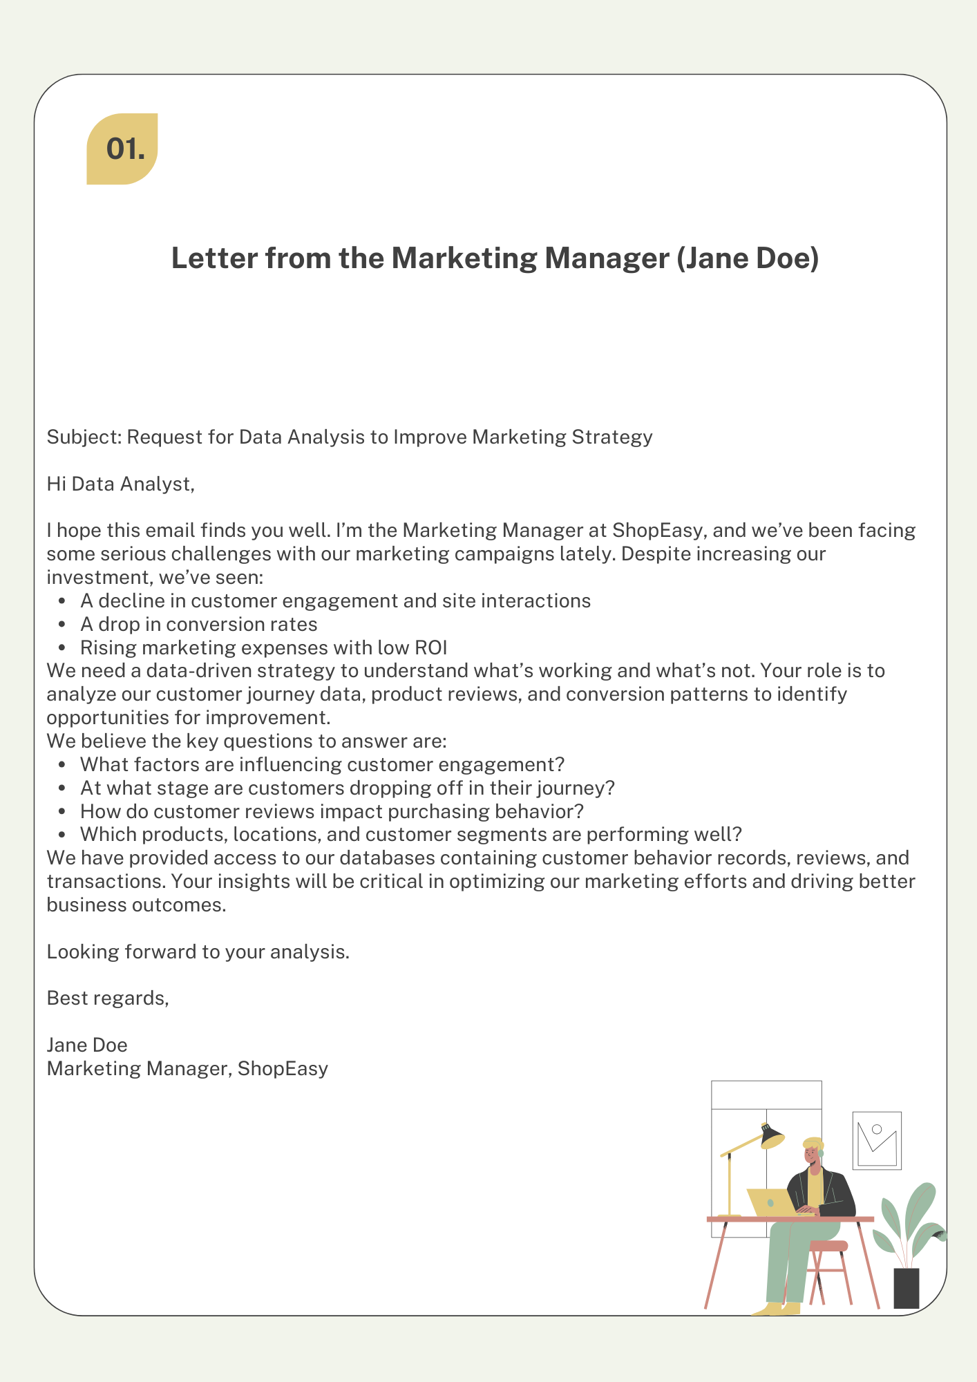

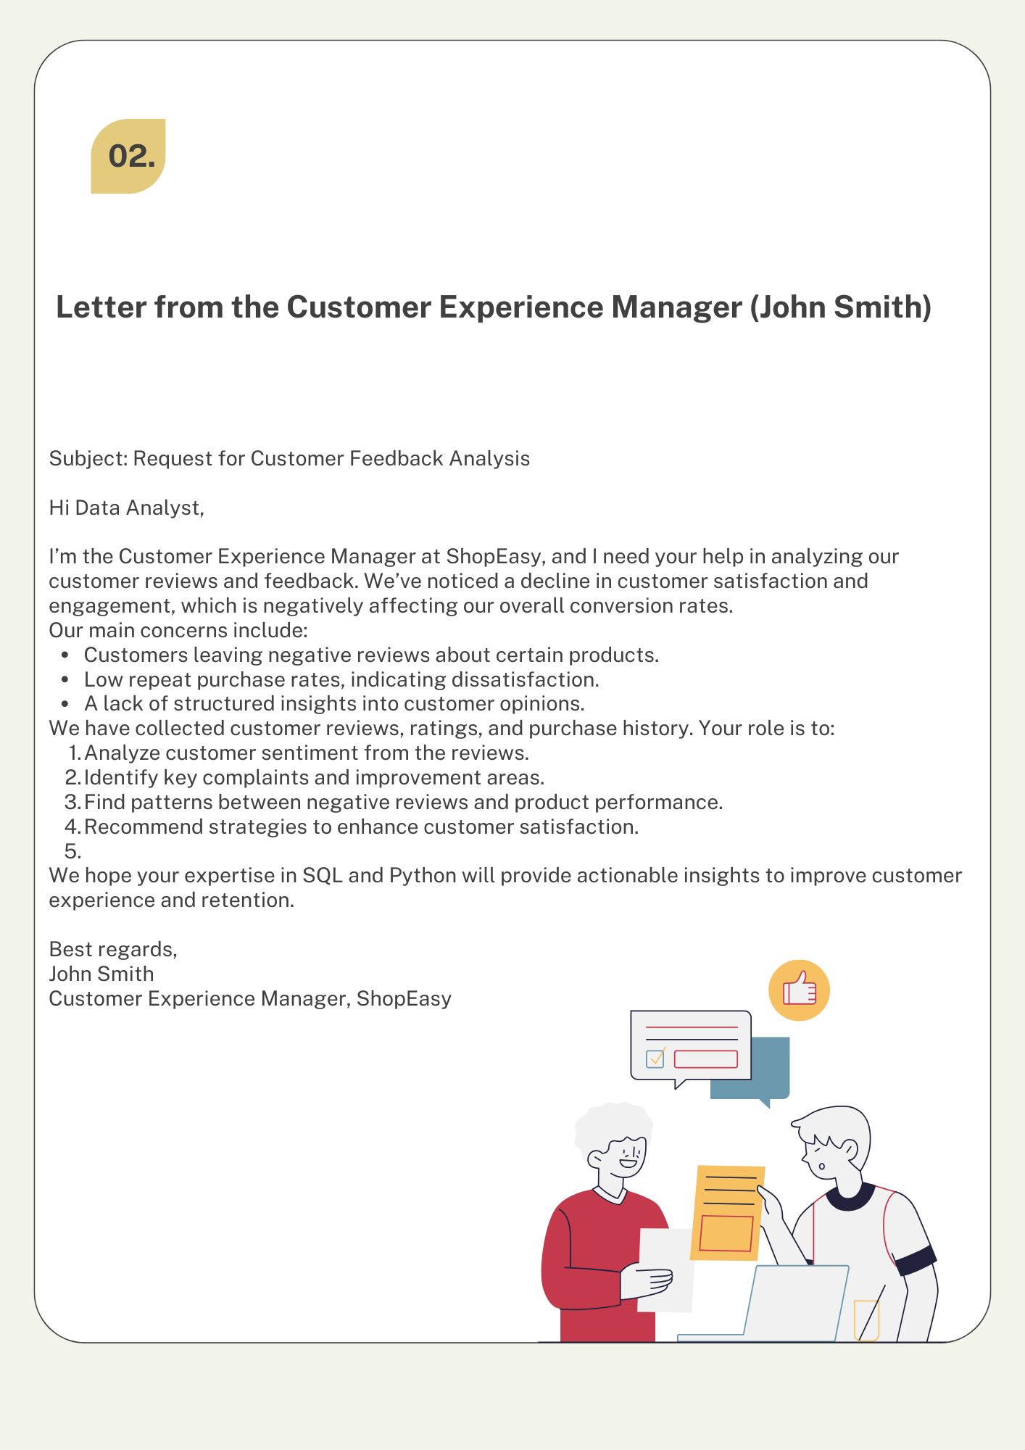

**ShopEasy is struggling with low customer engagement, poor conversion rates, and ineffective marketing strategies.** The business needs a **data-driven approach using SQL and Python** to analyze:

1. **Customer journey behavior** → Identify bottlenecks in the purchase process.
2. **Customer reviews & feedback** → Understand sentiment and satisfaction trends.
3. **Marketing effectiveness** → Measure the impact of engagement on conversion.
4. **Product & demographic analysis** → Identify high-performing products and customer segments.

The objective is to provide insights that will help **ShopEasy improve engagement, optimize marketing spend, and boost overall conversions**.

**📌 Business Use Cases:**

This project will leverage **SQL and Python** to extract meaningful insights from customer data, helping businesses:

* **Track customer journey progress** through different stages.
* **Analyze customer reviews** to understand sentiment and satisfaction.
* **Identify high-value customers** based on purchasing behavior.
* **Measure marketing effectiveness** through engagement and conversions.
* **Optimize product offerings** based on customer feedback.

**🛠 Approach:**

1. **Download CSV Files & Load Data into SQL (Python & SQL)**

* Download customer-related data from an external source (if applicable).
* Convert **CSV files into structured SQL tables**.
* Use **Python (pandas, SQLAlchemy, MySQL-connector, or psycopg2)** to automate data insertion.

1. **Data Extraction & Transformation (SQL & Python):**

* Write **SQL queries** to extract relevant data.
* Perform **joins** to integrate multiple datasets.
* Apply **window functions, CTEs, and subqueries** for deeper insights.

1. **Customer Journey & Engagement Analysis (SQL):**

* Identify **drop-off points** in the customer journey.
* Find **common actions leading to successful conversions**.
* Calculate **average duration per stage** for engagement insights.

1. **Customer Reviews Analysis (SQL & Python):**

* Identify **highest-rated and lowest-rated products** using SQL.
* Perform **basic sentiment analysis** in Python.
* Correlate **review trends with product performance**.

1. **Marketing Effectiveness (SQL):**

* Calculate **customer retention rate**.
* Compare **repeat vs. first-time buyers**.
* Find **best-performing products per region**.

1. **Business Recommendations (SQL & Python):**

* Generate insights from SQL query results.
* Provide **recommendations on improving customer experience**.

**📊 Expected Results:**

* Well-structured **SQL tables** with cleaned data.
* **Python scripts** for automated data insertion & SQL execution.
* Actionable insights based on SQL query results.
* **Final report summarizing customer trends and key marketing factors**.

**📏 Project Evaluation Metrics:**

Define the metrics or criteria used to evaluate the success and effectiveness of the project.

**🛠 Technical Tags:**

SQL, Python, CSV Handling, Data Cleaning, Database Queries, Customer Behavior, Data Transformation, SQL Joins, Window Functions, CTEs, Sentiment Analysis

**Data Set:**

Link : [Customer Behavior Analysis](https://drive.google.com/drive/folders/1gLyD0aYGRiabsGyN3OYCc3R8ONNLL1PU?usp=sharing)

**📦 Project Deliverables:**

* **SQL scripts for table creation, data insertion, and queries.**
* **Python scripts for loading CSV data into SQL.**
* **Final Report with insights derived purely from SQL queries.**

**📌 Project Guidelines:**

* Use **Python (pandas, SQLAlchemy, MySQL-connector, or psycopg2)** for CSV to SQL insertion.
* Follow **clean SQL coding practices** (proper formatting, aliases).
* Use **Python to execute SQL queries** and automate analysis.
* Document all assumptions and observations in a **report**.
* Optimize SQL queries for **faster execution**.

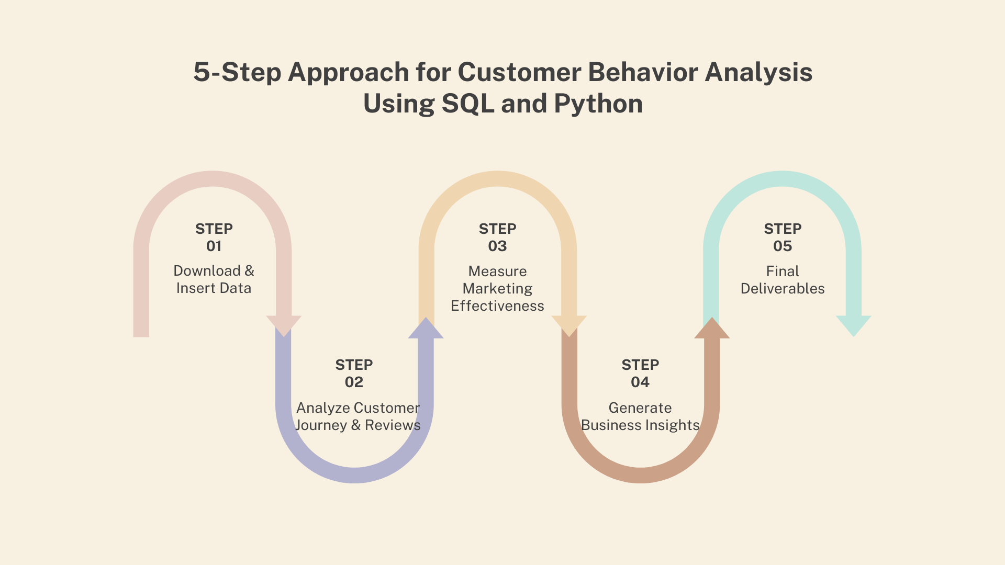

**⏳ Timeline**

The project must be completed and submitted within **10 days from the assigned date.**

**Reference**

| **Project Live Evaluation** | [**Project Live Evaluation**](https://docs.google.com/document/u/0/d/1QisLD2kqDWFZJG2oDknKn2eMGi-Xq8oFPgA7UWSbcIQ/edit) |
| --- | --- |
| **Capstone Explanation Guideline** | [**Capstone Explanation Guideline**](https://docs.google.com/document/d/1gbhLvJYY7J73lu1g9c6C9LRJvYemiDOdRDAEMe632w8/edit) |
| **GitHub Reference** | [**How to Use GitHub.pptx**](https://docs.google.com/presentation/d/1XHCbgUOqbcXNUyQ87vTlKdKRgAbBxtkA/edit?usp=sharing&ouid=109735616107417446342&rtpof=true&sd=true) |
| **Project Orientation (Tamil)** | [**Customer Behavior Analysis Session Recordings(Tamil) :**](https://docs.google.com/document/d/1qSRaq8Hi11lTwrRpbyBd3a6sF-mhMApV21RSTEvaTt4/edit?tab=t.0) |

**PROJECT DOUBT CLARIFICATION SESSION ( PROJECT AND CLASS DOUBTS)**

**About Session:** The Project Doubt Clarification Session is a helpful resource for resolving questions and concerns about projects and class topics. It provides support in understanding project requirements, addressing code issues, and clarifying class concepts. The session aims to enhance comprehension and provide guidance to overcome challenges effectively.

**Note: Book the slot at least before 12:00 Pm on the same day**

**Timing: Monday-Saturday (4:00PM to 5:00PM)**

**Booking link :**[**https://forms.gle/XC553oSbMJ2Gcfug9**](https://forms.gle/XC553oSbMJ2Gcfug9)

**LIVE EVALUATION SESSION (CAPSTONE AND FINAL PROJECT)**

**About Session:** The Live Evaluation Session for Capstone and Final Projects allows participants to showcase their projects and receive real-time feedback for improvement. It assesses project quality and provides an opportunity for discussion and evaluation.

**Note: This form will Open only on Saturday (after 2 PM ) and Sunday on Every Week**

**Timing: Monday-Saturday (05:30PM to 07:00PM)**

**Booking link :** [**https://forms.gle/1m2Gsro41fLtZurRA**](https://forms.gle/1m2Gsro41fLtZurRA)

| **Created By:** | **Verified By:** | **Approved By:** |
| --- | --- | --- |
| [**Shadiya P P**](mailto:shadiya@guvi.in) | [**Asvin Selvarajan**](mailto:asvin@guvi.in) | [**Nehlath Harmain**](mailto:nehlath@guvi.in) |